NodeMCU Buzzer on Arduino IDE

**1. Introduction:**

A buzzer is a device that is used to generate beep sound (generally a warning or alert in embedded system). It is a two leg device the longer leg is positive. If voltage is supplied it generates beep sound. Through analog write volume of beep can be controlled.

If a buzzer is switched with different time intervals it generates a melody..

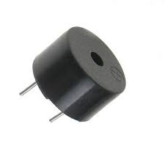

**1.2 Hardware required**

|  |  |  |
| --- | --- | --- |
| S.No. | Item | Quantity |
| 1 | NodeMCU | 1 |
| 2 | Breadboard | 1 |
| 3 | Transistor | 1 |
| 4 | Buzzer | 1 |
| 5 | LED | 1 |

**3. Programming:**

Once the circuit part is done, NodeMCU is needed to be programmed. Here is the code to run this circuit on NodeMCU.

int buzzer =  4;

void setup() {

 pinMode(buzzer, OUTPUT);}

void loop(){

 digitalWrite(buzzer, HIGH);

 delay(200);

 digitalWrite(buzzer, LOW);

 delay(200);

}

**4. Output**

The buzzer generates beep sound in a loop. Try delay in microseconds to generate melody. Volume is controlled through analogWrite. **TUNING A BUZZER**

By making few modifications in the code you tune the buzzer(ie.,make different sounds out of it).

Code:

Serial.begin(9600);

pinMode(buzzerPin, OUTPUT); //addigning pin to Output mode

void loop() {

tone(buzzerPin, 50);

delay(50);

noTone(buzzerPin);

delay(100);

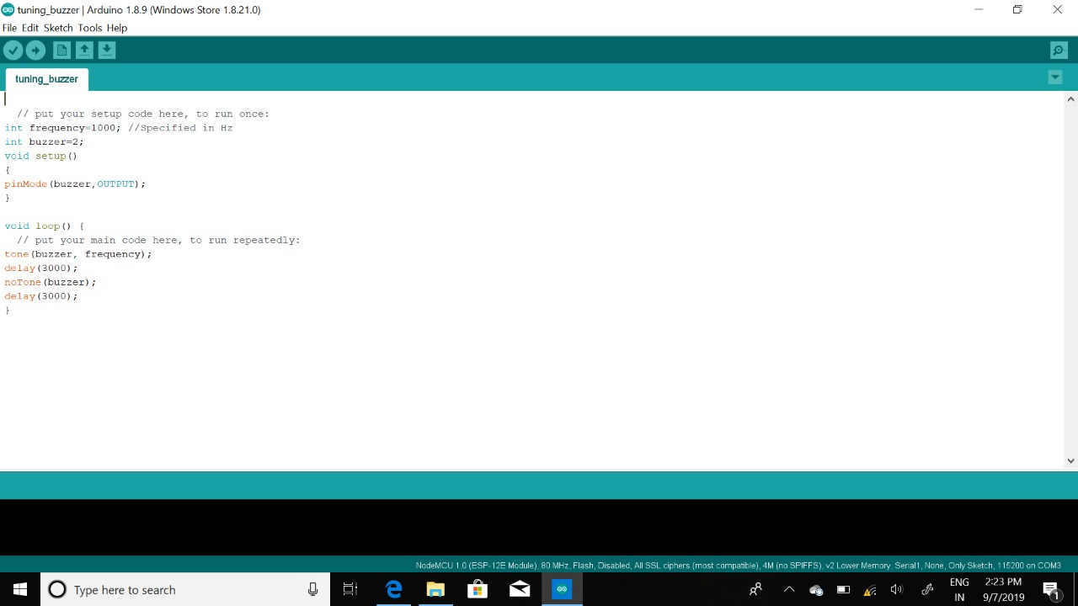

Connecting multiple buzzers:

Code:

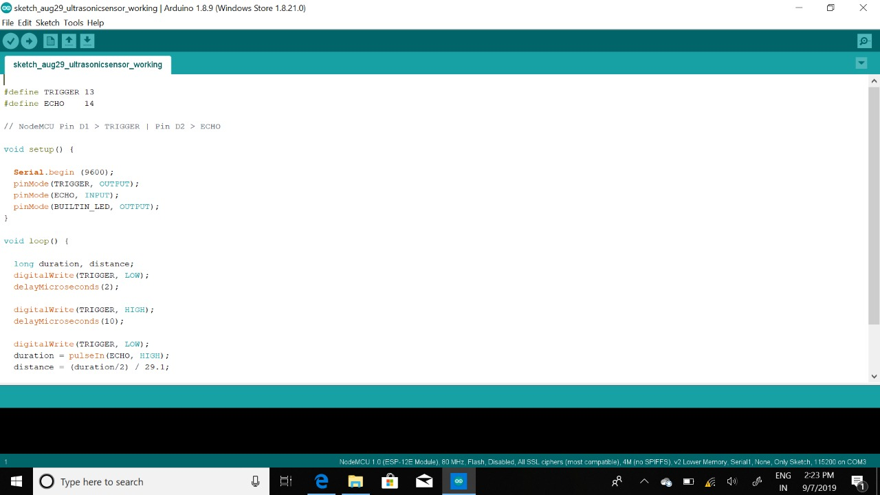

REGARDS:

NARSIMHA REDDY

DHEERAJ T

RAGASRI YARLAGADDA